NY DBL/PFL – Completing the Application
The application for NY DBL/PFL is a combined form. This must be completed and signed prior to implementation of a sold case. Use the proposal to complete the benefit and rate sections. This document highlights information to be completed page by page on the NY DBL/PFL Application. NOTE: The PDF form is an editable form, in which you or your customer may type the information directly into.
Page 1 of the Application
Enter the requested Effective Date.

Enter the Employer demographic and billing information.
  - Nature of Business - enter the SIC code from the DNB report.
  - Tax ID# - (TIN) Tax Identification Number also known as EIN (Employer Identification Number).
  - NY UI# - NY Unemployment Insurance Number (if available).
  - DBL & PFL Covered Employees - counts should be entered for the Male/Female for both DBL and PFL as these counts may be different.
  - DBL Monthly Covered Payroll – include if rates are based on a per $100 monthly covered payroll basis. May apply on groups 50 or more if underwriting released a quote on a per $100 MCP basis.
    - This would not apply to groups under 50 lives as those rates are canned rates on a PEPM (per employee per month).
    - Enter N/A when PEPM rates are selected (typically under 50 lives).
  - PFL Monthly Covered Payroll – (All Size Groups) always include this as it is needed for state reporting.
NOTE: This information is used to assist Maxon in calculating the annualized premium for the sales reporting. Maxon provides the sales reporting to the Compensation department each month so that the DBL/PFL credit can be entered into the sales compensation system.
    - For 2020 effective dates, if a person makes $72,860.84 or more a year, they are capped at the state annualized average weekly wage.
    - The annual salary cap is subject to change each January 1.
    - Use the PFL Monthly Covered Payroll Calculator to assist you in determining the PFL number of covered males/females and the PFL Monthly Covered Payroll. There are instructions, how to use this tool within the calculator. (See Example below)
      - Save the calculator for the group (the file name should include the name of the group) and attach it to the sold case email submission.
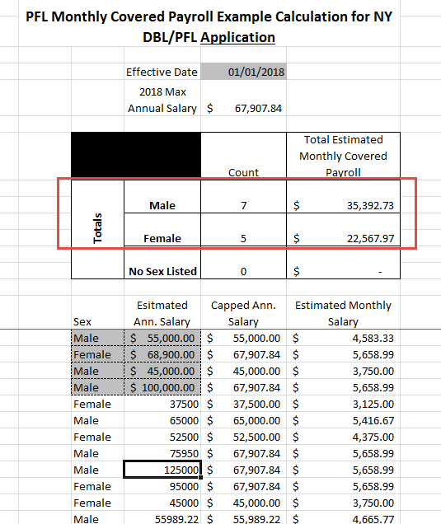

Page 1 of the Application (cont’d)

  - Non-Statutory Coverage Includes – This includes Teachers and/or Clergy are to be covered, please check the box. Other can be checked and show “employee(s) working in other non-statutory states (DBL ONLY). This would need prior approval from underwriting.
    - If you have questions about this field, contact DBL.Inbox@mutualofomaha.com for assistance.
  - Coverage Excludes – For example, union employees covered under their own union plan. Type Union on this line.
    - If you have questions about this field, contact DBL.Inbox@mutualofomaha.com for assistance.
  - Additional Entities/Location to be covered – This section should be completed when there are additional employees working in New York, in addition to the primary location listed.
    - Or, for covering employees working in other Non-Statutory states (DBL ONLY). Please provide a list of the non-statutory states where employees are working in.
    - If all of the additional locations fields are completed and you still have more locations to add, please attach a listing on a separate piece of paper with all of the fields listed in this section.
Example: Employer main location in Connecticut and they are including these employees (Non-statutory employees) and have employees working in NY. Then you need to complete this section to add the NY employees associated with this location.

  - Separate Billing by Locations – Yes or No
    - If Yes is selected, then a premium report will be sent to each location.
    - If No is selected, then the premium report will be sent to the primary location.

Page 2 of the Application
If the group has more than one class, please complete the additional Pages 2-3 of the form for each class. A situation where this may come into play for example could be class 1 Salaried employees have an enriched plan and class 2 hourly employees have a statutory plan.
Group Size (select one) – Select either 1-49 or 50+.
  - If the group size is 1-49, complete Section A.
    - Check the New York Statutory DBL Benefit Box.
      - Check the Employee Contribution that applies for DBL. None means non-contributory where employer pays 100% of the premium.
    - Check the New York Statutory PFL Benefit box.
      - Check the Employee Contribution that applies for PFL. The norm is 100% employee paid. If other is elected, please show the percent that the employer pays and percent the employee pays.
  - If the group size if 50+, complete Section B. These will be quoted by underwriting and released to the sales office.
    - DBL
      - If the Statutory Benefit is selected, check the gray line. This provides a 50% benefit, weekly maximum of $170, elimination period of 7 days/7 days for a maximum of 26 weeks.
      - If the Enhanced Benefit is selected, check the appropriate benefit requested under each section.
        - Check the Employee Contribution that applies for DBL.
- PFL
  - If the Statutory Benefit is selected, check the boxes under each section.
For 2020, this provides a 60% benefit of their Average Weekly Wage up to a weekly maximum of $840.70, no elimination period for a maximum of 10 weeks. (This amount changes each year. See page 5 of the application.)
  - If an Enhanced Benefit is selected, check the appropriate benefit requested under each section and fill in the benefit amounts. Underwriting approval would have occurred during the quote process.
  - Check the Employee Contribution that applies for PFL.

Page 3 of the Application
Billing Options:
- Check the requested billing option.
  - Quarterly in Arrears – this is the preferred option (BEST PRACTICE) and available for groups with 1-49 lives. The minimum amount billed for DBL is $15 per quarter.
Example: If the premium DBL is $12, the billed amount will be $15. The January – March bill would be sent out the middle of March. A premium payment is not required with the submission.
  - Monthly in Advance – billed the month prior and available for groups with 50 or more lives. Some exceptions can be made with less lives, please contact the underwriter.
Example: The March bill would be sent out the middle of February. A DBL and PFL premium payment in full is required with the submission. The policy cannot be issued until payment in full is received by Maxon Administrators.

DBL Premium Rate:
- There is a separate rate for DBL. Complete this section for the rate.
- If there is a Sole Proprietor/Partner, check this box and rate of $9.25 (Under 50 lives ONLY).
NOTE: The Sole Proprietor/Partner are subject to a different rate (unless Underwriting has approved otherwise during the quote process). Please provide their names in the next section.
  - The date the entity was established if less than 5 years old is needed for claims handling purposes based on the regulation.
PFL Premium Rate:
- There is a separate rate for the PFL. Please check the box and complete this section with the rate. The rate can be found on the page that is completed by the sales office. For 2020 the statutory PFL rate for male and female is .27%.

Page 4 of the Application
Signature:
- Have the document signed and dated by the Authorized Representative.

Page 5 of the Application
Sales Office Information Page

Complete the information about the sales office in the fields noted on this page.

Other Lines of Coverage with Mutual of Omaha
Check all of the applicable product boxes to indicate the other coverages this customer has with Mutual of Omaha.
- A new box has been added to indicate when we have sold the FMLA coverage.
  - This will alert Maxon to make the necessary update in their system to activate this group to be included with the interface program to send the DBL/PFL claim data to Absence Pro.

Complete the Employer and Broker information.
- The broker must have a Mutual NY appointment. Include the Producer/Firm numbers in this section of the form and completed the Producer/General Agent Checklist.
- If there is not a broker or the broker does not want to be appointed with Mutual of Omaha in NY, in the Broker Name field, enter Broker Direct. Note – when using Broker Direct, there is no contact made with the broker.
- Complete the Firm and Producer information to assist with processing of the sold case.

Customer Experience Tip:
The NY DBL/PFL application is an editable PDF form. Complete as much of the information from the proposal as possible prior to sending this form to your customer and, advise the customer this form is editable and to complete the remaining fields such as the Male / Female counts, PFL Monthly Covered Payroll. If the customer has any questions regarding any of the fields on the form consult with you. The customer would need to complete the remaining fields on the form and then sign and date (you can point out what is needed yet). Scan and return this completed form to us for processing.
Example: Fill in the Group Name, Address, SIC, rates, etc. and, the Sales Information page and save this document to send to your customer.

